SALEM CONNECTION

Salem Lutheran Church 21276 Archibald Road PO Box 100 Deerwood MN 56444

Pastor: Michael Briggs Phone: 218-534-3309 Email: office@salemdwd.org Website: www.salemdwd.org

“For by grace you have been saved through faith, and this is not your own doing; it is the gift of God.” - Ephesians 2:8

“Here I stand. I can do no other. God help me.” - Martin Luther

Be sure to wear red on Reformation Sunday, Oct. 27th, as we celebrate 502 years since the beginning of the Reformation. Do you know the story? Here’s a short history.

On Oct. 31, 1517, an unknown Roman Catholic monk and university professor named Martin Luther posted 95 theses on the door of the Castle Church (the town bulletin board) in Wittenberg, Germany. Luther wrote the 95 Theses to begin a debate in the church about the selling of indulgences – certificates of forgiveness of sins. Proceeds from the sale were being used to build St. Peter’s Basilica in Rome.

The ideas in the 95 Theses were wildly popular and quickly spread across Germany and Europe, thanks to a new invention called “the printing press.” In years to come Luther wrote numerous pamphlets (The Freedom of a Christian, The Babylonian Captivity of the Church, etc.) and enough books to fill 3 or 4 sets of encyclopedias, including translations of the New and Old Testaments into German, the Large and Small Catechisms, The Bondage of the Will, and many more. All of them were quickly printed and disseminated. Just as the internet makes it difficult for governments to control the spread of information today, so with printing presses running copies, neither the church nor the state could stamp out Luther’s ideas.

By 1520 Luther was excommunicated by the Pope and a price was put on his head. In 1521 Luther burned the letter of excommunication as an act of resistance, like Vietnam era men burned their draft cards. Later in 1521 Luther was summoned to the Diet of Worms. It wasn’t a new low carb diet – as appetizing and effective as that sounds. It was more like a congressional hearing. Emperor Charles V and many church officials would be there. Luther expected a chance to debate his ideas. Instead he was immediately asked to recant all his writings. He asked for a day to consider. When asked to recant the next day he uttered his famous words, “Unless I am overcome by the testimony of scripture or by clear reason (for I believe neither popes nor councils by themselves), I remain conquered by the scriptures… As long as my conscience is captive to the words of God, I neither can nor will recant, since it is neither safe nor right to act against conscience. Here I stand. I can do no other. God help me.”
Everybody knew Luther’s goose was cooked. On the way home to Wittenberg soldiers on horseback overtook his wagon, tied a hood over his head, and whisked him away to face his fate. They took him to Wartburg castle.
The soldiers were Frederick the Wise’s men rather than the Emperor’s. Frederick was not wild about Luther’s ideas, but as governor of the territory, he wanted to make sure his subjects were not bullied by the Church or imperial powers. We’d call it standing up for states’ rights.

Nobody could know Luther was at Wartburg of course, so he was disguised, and went by the name Knight George. He used his sabbatical time to translate the New Testament from Greek into German. Once it was published it became the first Bible written in the language of the people rather than Latin. (The King James Version, the first Bible published in English, came almost 100 years later).

In 1522 Luther went back to Wittenberg to help lead the political and religious changes sweeping across Germany – much like “the Arab Spring” swept across the Middle East a few years ago. In 1524 there was a freedom movement called the Peasants Rebellion. Luther took the side of the aristocracy – considered by many to be one of his many mistakes. Thousands of peasants were slaughtered. In 1525 Luther (a priest) married a nun named Catherine von Bora, embracing the principle of marriage for clergy. Katie ran the brewery that helped finance Luther’s work, and together they raised a family. Luther’s Large and Small Catechisms were published in 1529 to educate local pastors, parents, and children in the basics of the faith. In 1530 Luther’s colleague, Phillip Melanchthon presented the Augsburg Confession to the Emperor and Church officials at the Diet of Augsburg. (Luther couldn’t be there because he was still an outlaw). It was a last ditch attempt to find a theological formula for peace with Rome.

The 1530’s and 40’s were filled with increasing conflicts with Rome. Preaching, teaching and publishing continued, as did debates with humanists (Erasmus, etc.) and other reformers (the Anabaptists, Zwingli and the Swiss, etc.). Luther died in 1546 (probably kidney and heart disease). His last written words are a Reader’s Digest version of Paul’s words in Ephesians 2, “We’re all beggars. That is the truth.”
- Pastor Mike

PRAYER CONCERNS
Family of Myrt Bollenbacher, Shirley Taylor, Carol Bobich, Sandy Archibald, Teppi Bundy & family, Susan Barrett, Bill Boies, Jack Hales, David Olson, Gladys Cushman, Dan Goodwin, Ron Kretlow, George Pettersen, Mary Olson, Richard Leino, Cleone McGillivray, Mark Mitchell, Jill Martinson, Marsha Larson, Lochlan Mowers, Benita Harrison, Greg McBroom, Jeanne Astell, Renee Voller’s dad, Tim Cassady, Marion Mundt is recovering from pneumonia.

THANK YOU NOTES!

Thank you for all the prayers, cards, and flowers that have come my way.
Shirley Taylor

We want to thank all who prayed for our wellbeing. The phone calls and the cards sure helped to lift our spirits. We really are a church family. Praise God for such a blessing!
Ruth Helgesen & Glenn Suess

I’d like to thank my Salem Family for the prayers, cards and goodies while I recovered from surgery. I am glad to have it all behind me and am thankful for all the Doctors, nurses, family and friends for their help and wonderful care. Kris Schmidt

Dear ladies of Salem Church quilting group,
Thank you for continuing to donate such beautiful quilts for our baby ministry. I was so thankful and happy to get them from Maureen, and the moms receiving them will be too! They are so beautiful, colorful, and cozy. I really appreciate your time, talents, expenses, and T.L.C. that goes into each one of them. May God bless you for your generosity and kindness! Sincerely, Margee and Adrian
P.S. We have delivered 2,000 cribs in the past 7 years and thanks to caring donors like you, each has come with a lovely blanket or quilt!

ABOUT OUR SECOND SERVICE
When I was in prison, there were outside ministries that would come in for bible studies. One of the people that came once every month was a man named Mike from “White Stone” Ministry. Mike was an ex drug dealer who woke up one day, left the cities with his wife and three year old daughter, and became involved in prison ministry.

Over time I was the only person at his study. Mike was driving 80 miles to get to the prison. I told Mike I would understand if he didn’t want to drive 80 miles for his study, as I was the only one showing up for it. Mike said “As long as there is one ear to share God’s word with, it is worth the drive.” That’s how I feel about our second service!! Especially if one of the ears that hear is mine.
Glenn Suess and Ruth Helgesen agrees!!

ANNOUNCEMENTS

SALEM KIDS CLUB
It’s that time!! Kid’s Club at Salem begins on October 9th from 3:00 – 5:00 pm. Dates for October will be the 9th, 16th and 23rd. Look for November dates in the November Connection. Registration forms are on the bulletin board by the Fellowship Hall. You can turn them into the Office. Volunteers would be greatly appreciated! Contact Pastor Mike, Raye Cragun or Karla Peterson for more details.

FALL MUSIC REHEARSALS
Salem Cantata Choir will start practicing on October 7th. Rehearsals will be on Mondays from 5:30-6:30 (I believe this is the same as last year.) This year's cantata will be, “Ceremony of Candles” by Joseph Martin. Performances will be the weekend of December 7th-8th.

Salem Choir practices on Wednesdays, at 6:00 pm.
Salem Praise Team practices on Wednesday at 5:00 pm.
Salem Ringers practice on Mondays, at 7:15 pm.

Kennedy, Noreen, Becky, and Kevin invite you to join us. We gladly welcome part-time participants. Let’s make a joyful noise unto the Lord!

FALL FAMILY FESTIVAL at CAMP HIAWATHA
Bring your family and friends to join staff at Camp Hiawatha for an afternoon of canoeing, crafts, games, cookie and pumpkin decorating, campfire hotdogs and s’mores. YUM!! Sunday, Oct 6, 2:00-5:00. Cost is $5.00 per person with a $20.00 maximum per family. RSVP by October 3 to 218-246-8604 or more information at www.VLMcamps.org

SALEM WOMEN’S RETREAT
Just a reminder to get your registrations turned in for the Retreat on October 11th-13th. The theme this year will be "The Gift of Wonder" - creative practices for delighting in God. Focusing on Joy and what keeps us from it. It is based on John 10:10, an abundant life. We will again be joined by 8-10 women from First Lutheran in St. Paul, and Peggy is planning a fun craft. Registration forms are available on the welcome center at church. Please turn in your form/payment to the office. Hope you can make it this year… the colors should be spectacular on the island! Questions: Email/call Ellen. [218-866-0012]

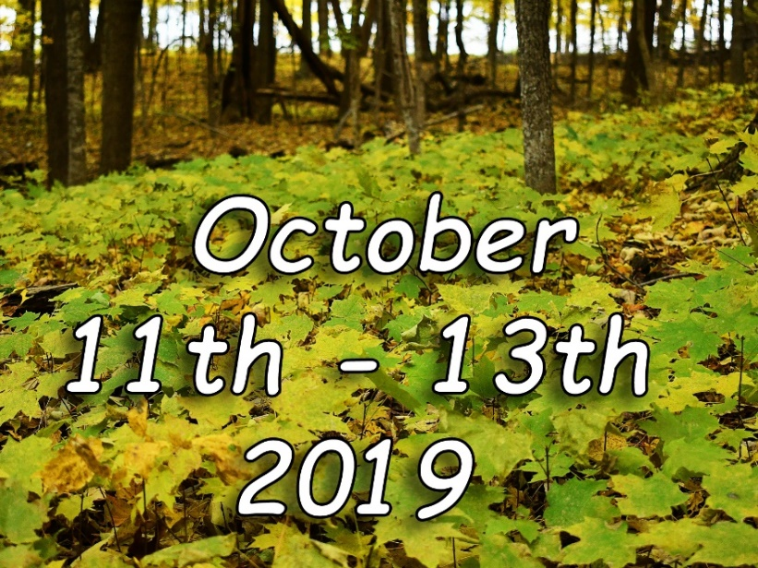

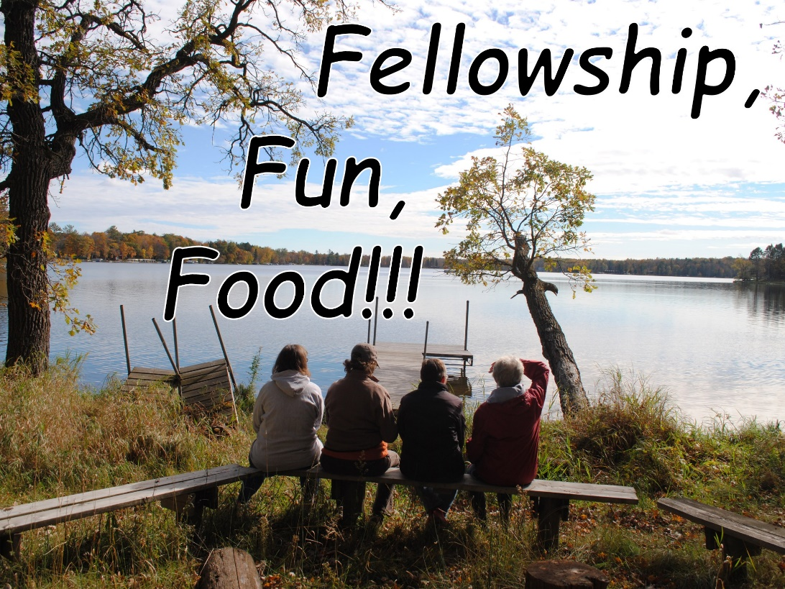

OCTOBER USHERS
October 6 -8:15 a.m.
Ed & Sherri Godfrey, John & Margo Wojciak
October 6 -10:00 a.m.
Ken Schultz, Glen Suess, Renee Gilmer

October 13 - 8:15 a.m.
Randy Holmvig, Herb & Barb Schoon, Helen Ryan
October 13 - 10:00 a.m.
Dean & Pat Sylvester, Ernie & Mary Erickson

October 20 – 8:15 a.m.
Chuck Lubowitz, Karla Peterson, Nory & Peggy Hunze
October 20 – 10:00 a.m.
Jay & Sue Stromberg, Lisa Slepica

October 27 – 8:15 a.m.
Clark & Joyce Marshall
October 27 – 10:00 a.m.
Roger & Marlene Prill, Pat & Laura Guimont

OCTOBER READERS
October 6 -8:15 a.m.
Cecil Schmidt
October 6 -10:00 a.m.
Myrna Nelson

October 13 - 8:15 a.m.
Kay Bendorf
October 13 - 10:00 a.m.
Jasmine Siliznoff

October 20 – 8:15 a.m.
Vi Klungness
October 20 – 10:00 a.m.
Glenn Suess

October 27 – 8:15 a.m.
Gary Guida
October 27 – 10:00 a.m.
Laura Guimont

OCTOBER COMMUNION SERVERS
October 6 -8:15 a.m.
Herb & Barb Schoon, Helen Ryan
October 6 -10:00 a.m.
Elsa Ray, Kris Schmidt

October 13 - 8:15 a.m.
Kay Bendorf, Doric C., Shirley Midthun
October 13 - 10:00 a.m.
Marlene Prill, Mary & Ernie Erickson

October 20 – 8:15 a.m.
Dale & Vi Klungness, Elaine Green
October 20 – 10:00 a.m.
Glenn Suess, Lisa Slepica, Nancy Johnson

October 27 – 8:15 a.m.
Gary & Becky Guida, Shirley Huxford
October 27 – 10:00 a.m.
John Cragun, Mark Boike, Renee Gilmer

CHURCH ATTENDANCE
August 25th 8:15 ~ 79
August 25th 10:00 ~ 46
September 1st 8:15 ~ 82
September 1st 10:00 ~ 48
September 8th 8:15 ~ 100
September 8th 10:00 ~ 51
September 15th 8:15 ~ 106
September 15th 10:00 ~ 47
September 22nd 8:15 ~ 110
September 22nd 10:00 ~ 43

OCTOBER ANNIVERSARIES
Joel & Kathy Hartman Oct. 1
Tim & Kim Coughlin Oct. 2
Wilbur & Arlene Radach Oct. 3
Ron & Laura Martin Oct. 7
Tim & Nancy Herberg Oct. 10
Bruce & Connie Lou Swanson Oct. 12
Pete & Laura Newton Oct. 14
Dean & Pat Sylvester Oct. 14
Myron & Shirley Midthun Oct. 15
Mark & Diane Boike Oct. 18
Cecil & Barbara Schmidt Oct. 18
Mark & Carla Kewatt Oct. 25
Gene & JoAnn Cordie Oct. 31

OCTOBER BIRTHDAYS
Josh Voller Oct. 1
Charlie Anderson Oct. 2
Shirley Huxford Oct. 2
Tracy Perpich Oct. 2
Jon Ross Oct. 2
Rick Stirewalt Oct. 2
Jack Voller Oct. 2
Richard Leino Oct. 3
Abigail Reed Oct. 4
Dean Sylvester Oct. 4
Kris Schmidt Oct. 5
Carole Nystrom Oct. 6
Polly Pflepsen Oct. 6
Meriellen Pisarek Oct. 6
Connie Lou Swanson Oct. 7
Diane Meyer Oct. 8
DeMar Wanstrom Oct. 8
Marshall Anderson Oct. 9
Michelle Muggli Oct. 10
Lynn Hansen Oct. 11
Mary Huntley Oct. 12
Brad Johnson Oct. 12
Shirley Midthun Oct. 12
Kris Davis Oct. 14
Dean Hansen Oct. 14
Josef Slepica Oct. 14
OCTOBER BIRTHDAYS cont...
Art Anderson Oct. 15
Steve Holmvig Oct. 15
Estyn Myers Oct. 16
Mina Nystrom Oct. 16
Ronald Kretlow Oct. 19
Mary Birtzer Oct. 20
Steve Thomas Oct. 20
Eleanor Pettersen Oct. 21
Gary Guida Oct. 22
Rachel Bundy Oct. 23
Jan Danger Oct. 28
Henry Hutchinson Oct. 28
Barb Schoon Oct. 28
Marlee Zender Oct. 29
Mike Bodle Oct. 31
Marlys Keefe Oct. 31

OUTREACH MINISTRIES
NIFTY NINETIES ~ Next meeting on Thursday October 3rd at 1:00 p.m. at Heartwood

DIAPER MINISTRY ~ Meeting to cut tshirts on Wednesday, October 9th at 9 a.m.

KOFFEE KLATCH at Heartwood, Friday October 11th at 11:00 a.m. Come for devotions and fellowship with Pastor Mike and friends.

PIECEMAKES QUILTING at Salem every Tuesday at 9:00 a.m.

IN STITCHES at Salem every Tuesday at 1:00 p.m.

WOMEN’S BIBLE STUDY ~ Wednesdays at 6:30 a.m.

MEN’S BIBLE STUDY ~ all men are welcome every Friday morning at 8:00 a.m. in the conference room.

TEAM/COMMITTEE MEETINGS
Facilities Team December 2nd, 6:00 pm
Worship & Music Team Tuesday, Oct. 1st, 5:30 pm
Faith Formation Team Tuesday, Oct. 8th, 6:00 pm
Executive Team Thursday, Oct. 10th, 5:00 p.m.
Outreach Governing Board Wed., Oct. 16th, 1:00 pm
Welcome Team – Tuesday Oct 22nd, 6:00 pm

Compensation Working Group Wed. Oct. 23rd, 3:00 pm

Council Mtg. Thursday, Oct. 24th, 6:00 p.m.

COFFEE HOUR ~ OCTOBER

Sunday, Oct. 6th
Josh & Renee Voller
Kristi, Madison & Taylor Bordwell
Sunday, Oct. 13th
Ken & Kathy Schultz
Jim & Sheila Mayne
Sunday, Oct. 20th
Clark & Joyce Marshall
Lynn Hansen
Sunday, Oct. 27th
Ed & Sherri Godfrey
Dick & Garnette Bordwell

THE MUSTARD SEED
Deb Selk, Manager mustardseed@salemdwd.org

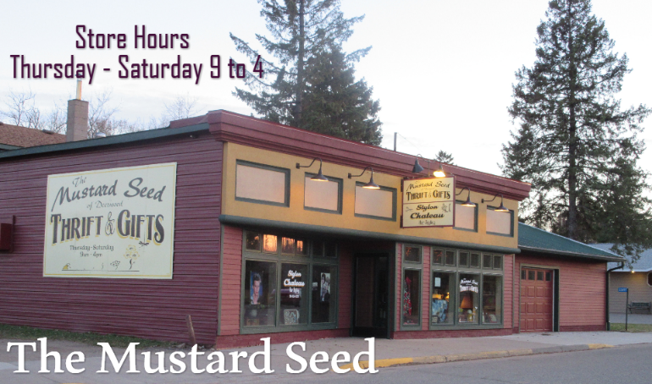

HAPPENINGS AT THE MUSTARD SEED
Fall is definitely in the air. We are working on getting the fall décor and Beautiful Fall Clothing
Out. We have tentatively set the Fall Volunteer Appreciation Dinner for Monday, October 21st.
More details to follow.

As the new addition is approaching done, we are looking for more Volunteers to help out here at the store. If you know anyone that is interested, PLEASE have them stop in.

I want to congratulate all the Volunteers and Staff here at the Mustard Seed for being voted 2nd
Place for the Best Thrift Store in the Brainerd Lakes Area! That is so Awesome! Thanks everyone for your dedication.

Blessings, Deb

FROM THE SALEM LIBRARY
October is a varied month. We can have summer-like days as well as cold, rainy days. We often see our first snowfall in October.
Our celebrations in October vary also. Halloween on October 31 (originally known as All Hallows Eve) was a religious holiday in the Christian church. Now it is a more secular holiday with costumes, decorations, trick or treating, etc.
October 31 is also known as Reformation Day, a day to remember the Protestant Reformation. This is because Martin Luther is said to have nailed his Ninety-five Theses to All Saints’ Church in Wittenberg on All Hallows Eve.
Salem’s library has on display books and DVD’s about Martin Luther and the Reformation for you to check out and learn more about this important celebration in our Lutheran church.
You may have noticed that it is getting dark earlier and nights are cooler. This is a perfect time to find a comfortable spot to read a book. The Salem Library has fiction, biography and non-fiction for you to select.
Our next library team meeting will be October 15 at 3:00. We would welcome new members!!
TRUNKS for TREATS!

It’s that time of year again! We are looking for volunteers for our annual Trunks for Treats event. This is a fun Salem tradition and if you haven’t participated in the past, stop by and see what you have been missing!! Trunks for Treats provides a safe, traffic free area for little ones to trick or treat. Individuals, families, groups/friends or committees may set up vehicles (trunks) in the parking lot and then hand out candy to area trick or treaters from 4:30-6:00 pm.

Please provide your own candy. Have fun decorating your car and/or yourself (optional). If you prefer to hand out your candy inside, we will have tables set up to display your goodies. No scary costumes please!

Again this year, we are inviting area businesses and churches to set up and join us in the parking lot!

Not interested in sitting outside on October 31st? We need help inside also. Hotdogs and beverages will be served to kids and families in the fellowship hall. We’ll need help setting up, serving, cleaning up and of course welcoming families into our church.

There is a sign-up sheet in the narthex. Please sign up if you are interested in helping. Candy donations are needed and appreciated. Please place in the collection box located in the narthex. Contact Kris Schmidt 218-851-1362 with questions.
If you have little ones trick or treating this year, be sure and stop by!

Salem Lutheran Church Faith Formation Team

The Faith Formation Team members have been working to organize and carry out Faith Formation activities and events until the Council decides how best to meet the needs of the congregation.

Raye Cragun and Marlene Prill are leading Sunday school. They are looking for volunteers willing to substitute occasionally or to be on call for days when there are more children attending. Please let them know if you are available to help.

Kid's Club will begin October 9. Karla Peterson, Raye Cragun, and Mark Carlson have begun planning fun, educational, and entertaining sessions for the year. Mary Erickson and Carol Malek will prepare snacks for Kid's Club.

If you are interested in helping with activities, sharing Bible stories, leading small groups, teaching a craft or skill, providing food or serving, contact these people. Kid's Club is a rewarding way to connect with young people from our church and our community.

PRAYER BUDDIES

We would like to continue our Prayer Buddy program this year. Forms are available on the Welcome table in the narthex.

Parents may complete a form requesting prayers for their child during the school year.

Salem members who are willing to pray for a specific child every day should complete a form and they will be matched up with a child. We encourage you to send a card to the child you pray for on their birthday or holidays. No gifts, please. Even members who travel can pray from wherever they are.

When the forms are returned, the Faith Formation Team will pair each child with a prayer buddy for the school year.

The next Faith Formation Team meeting will be October 8th at 6:00 p.m.

Salem Lutheran Church Facilities Team Minutes of September 16th, 2019
Facilities team meeting minutes September 16, 2019
Present were Lois Hicks, Mark and Debbie Carlson, Mike Shamrock, Ernie Erickson, Roger Prill, and Pat Guimont.
Absent: Louis Smilach, Ed Godfrey, Randy Holmvig, Carol Malek, Terry Fields, Don Hales, Joel Huntley, Ken Schultz and Rad Royer
1. Minutes from last meeting were accepted. Mike Shermock made a motion, and Lois Hicks seconded it.
2. Glen’s replacement: Debbie and Mark Carlson, they will take on all the duties Glen did except for mowing grass and Mustard Seed, for six months ending the last week of February of 2020
3. Dishwasher has been leaking on the floor, the plunger and screen basket is letting water drain down drain. Mark will order new parts, and Ernie will help him fix it.
4. Parking Lot: Crack filling and stripping were done. Need to find out if Bank was presented their half of the bill for stripping. There half would be $250.00
5. The new organ speakers contract has been signed and sent to contractor.
6. Columbarium will be cleaned up and winterized during the fall cleanup.
7. Outside concrete repair: Mike Shermock has had one estimate to have work done and will be working on one more.
8. LED electric sign project. The committee members are Harry Kahnart, Ernie Erickson, Kay Cooper, Helen Ryan, and Pat Sylvester. Ernie gave report on the progress.
9. Need to move freezers from Summerfest to shed, and still need shelving for pantry. Decided to keep washer and drier in case it is needed in future.
10. Cleaning of ceiling projectors and ceiling fans. Electronic people are working on repair or new projectors on rear projector in sanctuary and the one in fellowship hall.
11. Mowing and snow shoveling at Mustard seed... Josh is dong the mowing. It was decided to let the social ministry committee take care of hiring someone to do the shoveling. Josh Schiffler is taking care of the lawn mowing.
12. Josh has fertilized the grass around church grounds because it was not looking good and is cutting it longer with his mower. Looking better now.
13. Someone has offered a four wheel handicap chair. Decided to take it and get rid of one of the two wheel chairs that we have now that is in bad shape.
14. Fall cleanup will be Oct. 12th starting at 8:00 am, morning only. Might have to add cleaning rain gutters also. Have Randy Holmvig ask if Sherri’s trailer will be available for this cleanup.
15. New Business: Chuck Lubowitz to take care of Oxygen tank and defibrillator.
16. There are some items left from Summerfest that need to be taken care of in dumpster area by Salem West.
17. Next meeting December 2, 2019 6:00 pm
18. Decorate church for Christmas. December 2, at 9:00 am
19. Meeting adjourned.
Outreach Governing Board August 21, 2019

Salem Outreach Committee Meeting August 21, 2019
Present were Don Hales, Noreen Steinbrecher, Terry Tichenor, Kim Coughlin, Joyce Kohnen, and Pastor Mike absent.

MSC: Motion, Seconded, and Carried

Meeting was open by Noreen Steinbrecher with some phrase of life lessons and prayer.

Secretary minutes from July 18, 2019 was approved with the addition of email motion to add a 14X14 concrete pad at the rear of the new MS building. MSC

Financials: Review
Don Hales and Terry Tichenor plan to go and have a portfolio review with our investors.
Motion to move monies from:
#2910 (Operating Reserves) to move $1000.00 to line # 7140
#2910 (operating Reserves) to move $1500.00 to line #7205
#2910 (Operating Reserves) to move $1500.00 to line #7540 to be split between MS and SW for volunteer appreciation.
#2800 move $5296.12 to #8110 for Ericka’s wages. MSC

Summerfest was very good this year. The rummage sale at the MS made about $3000.00. Summerfest for Social Outreach will be a little over $11,000.00.

Scrip orders for July was $67.34 Total so for this year is $390.88.

Need to replace Bev Kunz as she has taken the assistant job at MS. Looking for temporary replacing her for balance of the year.

Joey’s anniversary date is coming. Motion was made to go ahead with his raise. MSC

Mustard Seed is down in sales.

Addition:
Clay Alexison bid $83,000.00 Actual bill $83,695.00
Jerry Hutchison bid $24,265.00 Actual bill $24,265.00 owe $9265.00
TWM bid $6,000.00 Actual $6600.00 owe $600.00
HVAC bid $1906.00
Electric bid $6700.00
Interior Finishing bid $8445.00
Total $131,611.00 balance due $26,916.00
Money to finish the interior will come from Operating reserves.
Motion to move the $1500.00 (#2835) from 200 Salem Outreach to 300 Mustard Seed acct. lateral move to 0 out the 200 Salem Outreach.
Move $17,874.47 from #2370 to line #2835
Move $25,000.00 from line #2910 to line #2835 MSC
Motion to pay the following bills from line #2835
Jerry Hutchison $9265.00
TWM $ 600.00
HVAC $1906.00
Electric $6700.00
Interior $8445.00

Motion made to pay Jerry Hutchison for repair to parking lot for $1980.00 from line # 2836. MSC
Sale West:

Motion to make Erika’s job as a permanent position. Will be sent to council for approval. Her title will be called Salem West Inventory Coordinator MSC

Motion was made to delete #2874 and #2895 as liabilities. MSC

Next meeting will be October 18 at 1:00pm.
Summitted by Sandy Kretlow Secretary

Volunteer Appreciation Dinner
The date has been set for this Falls Appreciation Dinner, it will be held October 21st. This is open for everyone who volunteers in anything at Salem. Please come and enjoy an evening with your fellow volunteers and friends.
Don

Sunday | Monday | Tuesday | Wednesday | Thursday | Friday | Saturday
29  8:15 AM Traditional Worship  10:00 AM Contemporary Worship | 30  Pastor Out of the Office  7:15 PM Ringers Practice | 1  9:00 AM Piecemakers  1:00 PM In Stitches  5:30 PM Worship & Music Committee Mtg. | 2  6:30 AM Women's Bible Study  11:00 AM Staff Meeting at Salem West  3:00 PM Compensation Working Group Mtg.  5:00 PM Praise Team Rehearsal  6:00 PM Choir Rehearsal  7:00 PM Confirmation Class | 3  1:00 PM Nifty Nineties at Heartwood | 4  8:00 AM Men's Bible Study | 5
6  8:15 AM Traditional Worship  9:30 AM Nominating Committee Mtg.  10:00 AM Contemporary Worship  11:15 AM Confirmation Planning Mtg. | 7  Pastor Out of the Office  12:30 PM - 3:30 PM Cuyuna Range Women's Club Mtg.  5:30 PM - 6:30 PM Cantata Rehearsal  7:15 PM Ringers Practice | 8  9:00 AM Piecemakers  1:00 PM In Stitches  6:00 PM Faith Formation Team Mtg. | 9  6:30 AM Women's Bible Study  9:00 AM Diaper Ministry  10:30 AM Staff Meeting  12:00 PM Welcome Committee Mtg.  3:15 PM - 5:00 PM Kid's Club  5:00 PM Praise Team Rehearsal  6:00 PM Choir Rehearsal  7:00 PM Confirmation Class | 10  9:30 AM Sarah's Circle  12:00 PM Grief Group  5:00 PM Executive Team Mtg. | 11  8:00 AM Men's Bible Study  1:00 PM Koffee Klatch at Heartwood  5:00 PM - 5:00 PM Salem Women's Retreat begins | 12  Women's Retreat  8:00 AM - 12:00 PM Salem Fall Clean Up Day
13  Women's Retreat  8:15 AM Traditional Worship  10:00 AM Contemporary Worship | 14  Pastor Out of the Office  9:00 AM - 11:00 AM Unlimited Learning Mtg.  5:30 PM - 6:30 PM Cantata Rehearsal  7:15 PM Ringers Practice | 15  Pastor Mike out of the Office  9:00 AM Piecemakers  1:00 PM In Stitches  3:00 PM Library Team Mtg. | 16  6:30 AM Women's Bible Study  10:30 AM Staff Meeting  1:00 PM Outreach Governing Board Mtg.  3:15 PM - 5:00 PM Kid's Club  5:00 PM Praise Team Rehearsal  6:00 PM Choir Rehearsal  7:00 PM Confirmation Class | 17  MEA  6:00 PM Council Mtg. | 18  MEA  8:00 AM Men's Bible Study  9:00 am-noon  Fall Cleanup at Salem | 19  David Olson Funeral  10:30 am visitation  11:30 am Service
20  8:15 AM Traditional Worship  10:00 AM Contemporary Worship | 21  Pastor Out of the Office  5:00 PM Fall Volunteer Appreciation Dinner  7:15 PM Ringers Practice | 22  NEWSLETTER ARTICLES DUE  9:00 AM Piecemakers  1:00 PM In Stitches  6:00 PM Welcome Team Mtg. | 23  6:30 AM Women's Bible Study  10:30 AM Staff Meeting  3:00 PM Compensation Working Group Mtg.  3:15 PM - 5:00 PM Kid's Club  5:00 PM Praise Team Rehearsal  6:00 PM Choir Rehearsal  7:00 PM Confirmation Class | 24 | 25  8:00 AM Men's Bible Study | 26
27  8:15 AM Traditional Worship  10:00 AM Contemporary Worship | 28  Pastor Out of the Office  5:30 PM - 6:30 PM Cantata Rehearsal  7:15 PM Ringers Practice | 29  9:00 AM Piecemakers  1:00 PM In Stitches | 30  6:30 AM Women's Bible Study  10:30 AM Staff Meeting  3:15 PM - 5:00 PM Kid's Club  5:00 PM Praise Team Rehearsal  6:00 PM Choir Rehearsal  7:00 PM Confirmation Class | 31  4:30-6:30 pm  Trunks for Treats at Salem | 1  8:00 AM Men's Bible Study | 2

SALEM STAFF CHURCH COUNCIL
Pastor – Michael R. Briggs Mark Carlson, VP 218. 851. 7236
Office Manager – Tammy Martin Jake Frahm 218. 772. 0202
Financial Manager – Chanda DeVilliers Diane Hein, President 218. 678. 2699
Facilities Coordinator – Glen Helm Joel Huntley 218. 892. 0360
Organist/Pianist – Becky Klingelhofer Meriellen Pisarek, Secretary 218. 839. 3608
Choir Director – Kennedy Niska Ken Stebbins 218. 764. 2587
Handbell Choir Director – Kevin Edstrom Terry Tichenor, Treasurer 781. 223. 0258
Praise Team Directors – Becky Klingelhofer/Noreen Steinbrecher John Wojciak 218. 546. 5983
Director of Outreach – Don Hales Jeff Mitchell 651. 260. 8140
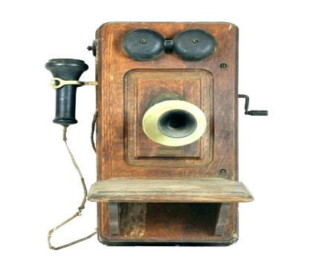
Salem Outreach Facilitator – Dee Dee Frahm
Salem West Manager – Dennis Peterson
Salem West Delivery Leader – Steve Weishalla
Mustard Seed Manager – Deb Selk
Mustard Seed Assistant Manager – Julie Fritz
Mustard Seed Assistant Manager – Bev Kunz
Mustard Seed Assistant – Joey Serfling

EMAIL ADDRESSES
Pastor Mike pastor@salemdwd.org
Tammy Martin office@salemdwd.org
Chanda DeVilliers finance@salemdwd.org
Glen Helm facilities@salemdwd.org
PHONE NUMBERS
Salem Lutheran Church: 218.534.3309
Salem WEST (giving ministry): 218.534.4962
Mustard Seed: 218.534.2945

The Mustard Seed mustardseed@salemdwd.org
Deb Selk msmanager@salemdwd.org
Salem WEST west@salemdwd.org
Don Hale outreach@salemdwd.org

VOLUNTEER MINISTRY COORDINATORS
Wedding Coordinators: Kim Coughlin, Sherri Godfrey
Cradle Roll: Jessica Jones
Altar Care: Barb Schiffler
Control Booth & Website: Meriellen Pisarek
Kitchen Coordinators: Sherri Godfrey, Kathi Sharp
Communion servers & Readers: Nancy Meyer
Ushers: Roger Prill
Memorial Committee: Cathy Aykens
Care & Share: Marlene Prill, Sandy Kretlow
Technology Team: Meriellen Pisarek

THANK YOU TO ALL OUR SALEM VOLUNTEERS!!

